GREENO2 - Green Roofs in higher education institutions as sustainable cEnters for research, participation, ENvironmental consciousness and O2 generation

1st Press Release
-November 2023-

About the project

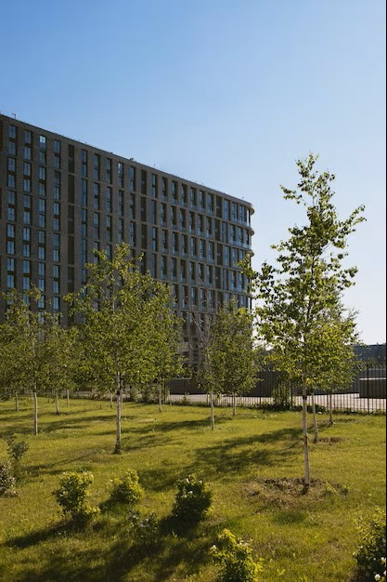
The GREENO2 project seeks to encourage green roofs as sustainable hubs for research, community involvement, and environmental awareness within urban universities. This initiative aligns with the European Green Deal’s recognition of universities’ pivotal role in engaging students and the broader community for a more sustainable future. GREENO2 is guided by the European Commission’s strategies on climate change adaptation in 2021 and the 2030 EU Biodiversity Strategy, which emphasize the use of green roofs to restore urban biodiversity.

GREENO2’s primary focus is on the green infrastructure of urban higher education institutions, driven by the belief that architecture can profoundly influence our learning and behavior. Additionally, it advocates for green roofs as tools to empower learning, enhance environmental consciousness, and foster active participation within the academic community.

In essence, this project addresses the challenge by involving the academic community and promoting the advantages of implementing various types of green roofs
in urban institutions to create a greener and more sustainable future.

The main objectives of the project are:
Promote green roofs as the academic community’s response to environmental protection, active participation & well-being in higher education
- Provide environmental awareness education through green roofing
- Encourage the implementation of green roofs as centers for research and environmental consciousness, study and/or recreation areas, etc.
- Deliver innovative training digital tools based on differentiation
- Create digital support center, which will provide specialized and personalized information on green roofs depending on the needs or the preferences of target roofs

The target groups of the project are:
- higher education students, academics, trainers, tutors and administrative staff

The 7 partners involved are:

1.UNIVERSITA DEGLI STUDI DELLA TUSCIA
2. Panteion University of Athens
3. XENIOS POLIS
4. University of CADIZ
5. Akademia Kultury Spolecznej i Medialnej
6. GRIPEN EUROPE SRL
7. LIM Srl Unipersonale
8. TARAS SHEVCHENKO NATIONAL UNIVERSITY OF KYIV

from 6 different countries, Italy, Greece, Spain, Poland, Romania and Ukraine.

1st official transnational meeting

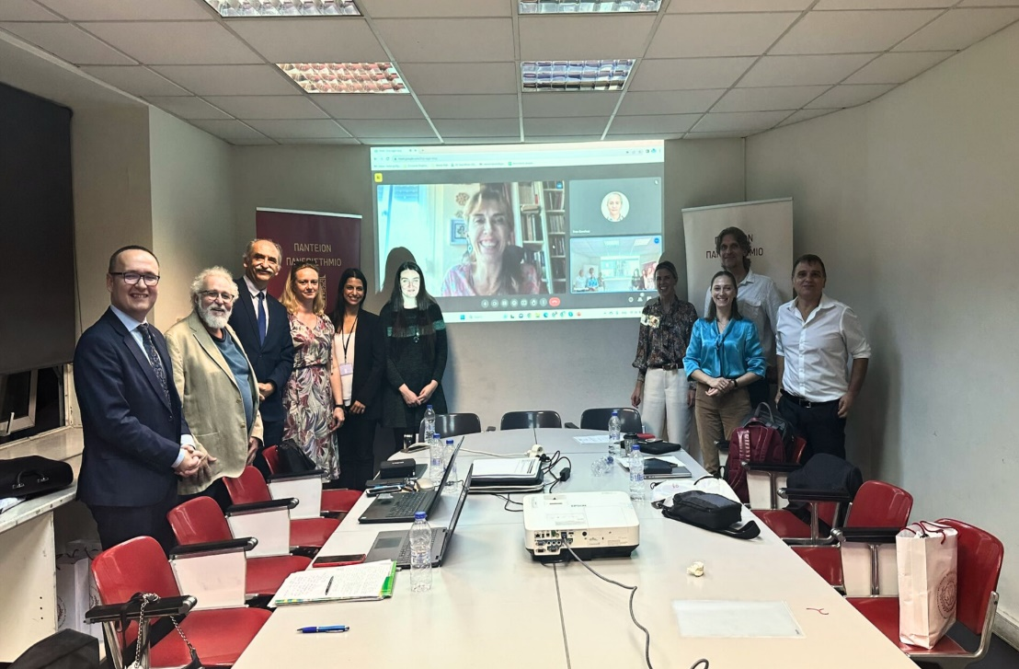
The organisations involved in GREENO2, had the opportunity to meet each other for the kick-off of the project, in October 2023, in Athens, Greece. The meeting was hosted by the partner Panteion University of Athens and provided the opportunity to the consortium to introduce their organisations, while the University of Tuscia, as the project coordinator, presented the objectives and the overall tasks to be implemented throughout the project. The partners presented the activities to be undertaken on behalf of their team, regarding the WPs (Work Packages):

WP1: Management
WP2: GREEN-O2 RSPM – Research, Scientific Production & Pedagogical Methodologies
WP3: GREEN-O2 Digital Toolset
WP4: Communication, Dissemination and Networking

Consequently, some milestones were set. Partners not only scheduled their tasks for the upcoming months, but also reflected on their experiences regarding the topic of the project (Green Roofs) in general, the legislation and the best practices that are taking place in their countries respectively. These are to be taken into consideration for the 2nd task (Research and Curriculum Modules Development) of the WP2 in the following months.

In addition to the above, the website of the project is being developed to support both the dissemination procedure and the digital platform of the project.

GREENO2 Website

The second transnational partners’ meeting is scheduled for April 2024, in Cadiz, Spain .

